**ITIS 6400 Human Computer Interaction**

**Spring 2018**

**Class Activity – Information Architecture and Web Design critique**

**Names: Snigdha Bose, Robert Corzine, Poorna Chandrika Maddisetty, Monte Nagahisarchoghaei**

This activity has two parts. The first is to develop an information architecture, and the 2nd is to critique an existing web site with respect to navigation, information organization, visual design.

**Part 1: Information architecture (Spend 25 minutes at most on this, so work quickly)**

Create the information architecture for the College of Computing and Informatics website. Do not look at the existing web site until you are done! You do not need to re-create the existing structure, but instead think about what you want in an ideal structure.

1. Brainstorm all the different information/pages that should appear on the website. For example, a list of faculty or degree details. List each of these on a post-it.
2. Group the post-its on a wall or on your table into categories. Use these categories to decide the menu bar, and submenus that should appear on the web page. This can be hierarchical – for example, you might decide there should be a People menu, and under that a Faculty option.
3. Take a photo, or type or write in your organization on paper.

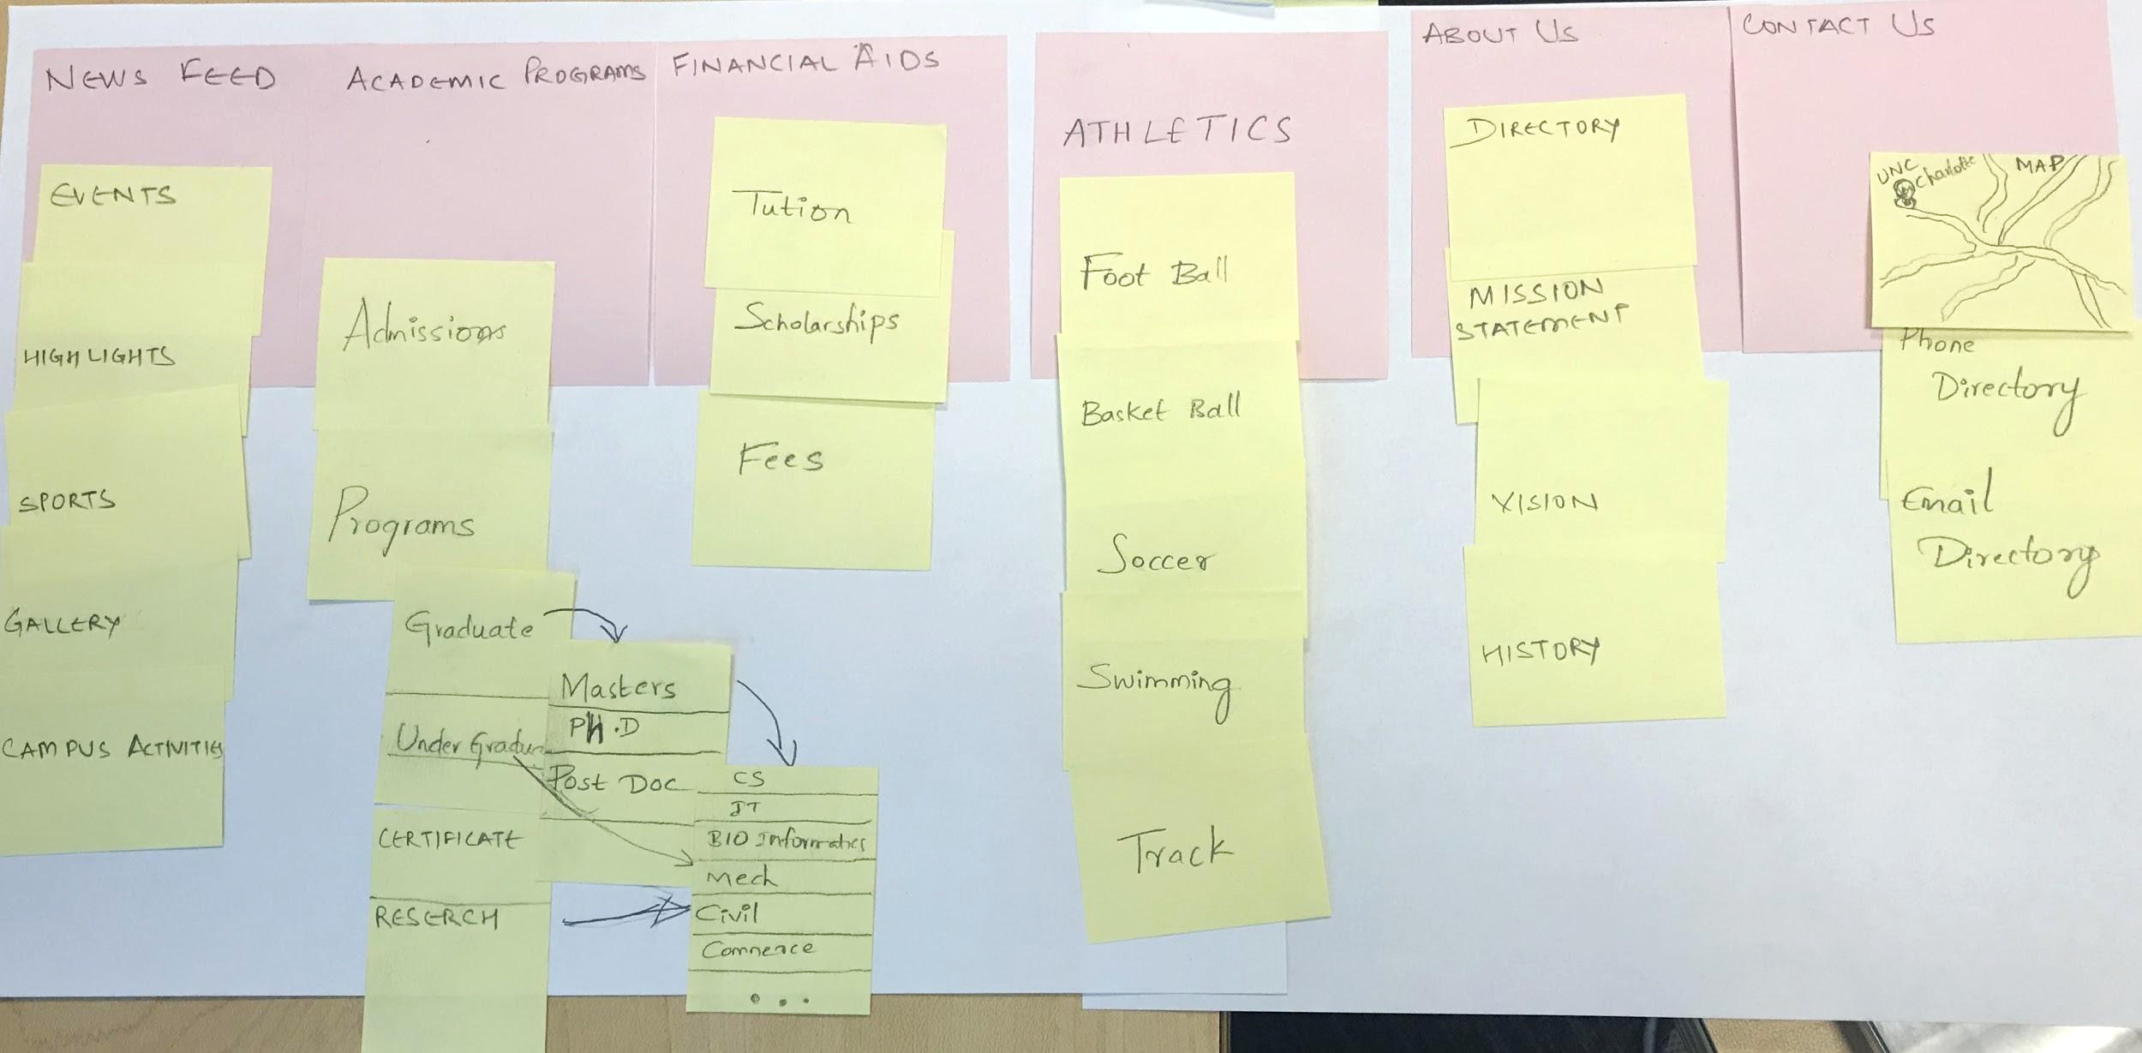

**Part 2: Website critique (Spend 25 minutes on this)**

Now critique the College of Computing website – <https://cci.uncc.edu>. Comment on what is good, and what you think is not so good. Consider the wide range of users who might use this website.

1. **Content and structure:**

Critique the organization of the menu structure: Is the site organized as expected? Are there missing options? Or options you think should go elsewhere?

Also critique the content on the pages – in particular, what content is on the home page and the landing pages? Is that what should be there?

**Our views:**

* We would move the about us menu to the end and replace its position with the media/news menu because of important news and updates.
* We believe that departments menu should be taken out because it should be under the academics menu. Mapping Departments with Academic programs would be a better structure and more comprehensive.

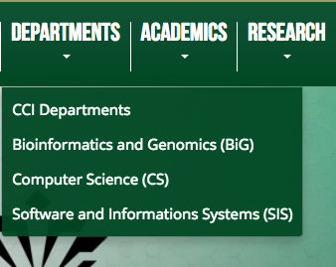

* The top Menu items with Alumni and Community can find place in the second Main Menu under a Single tab.
* The image on the home page may be decreased in size to accommodate more important information at the top of the Web-page without the requirement to scroll right to the bottom of the Page below the fold.

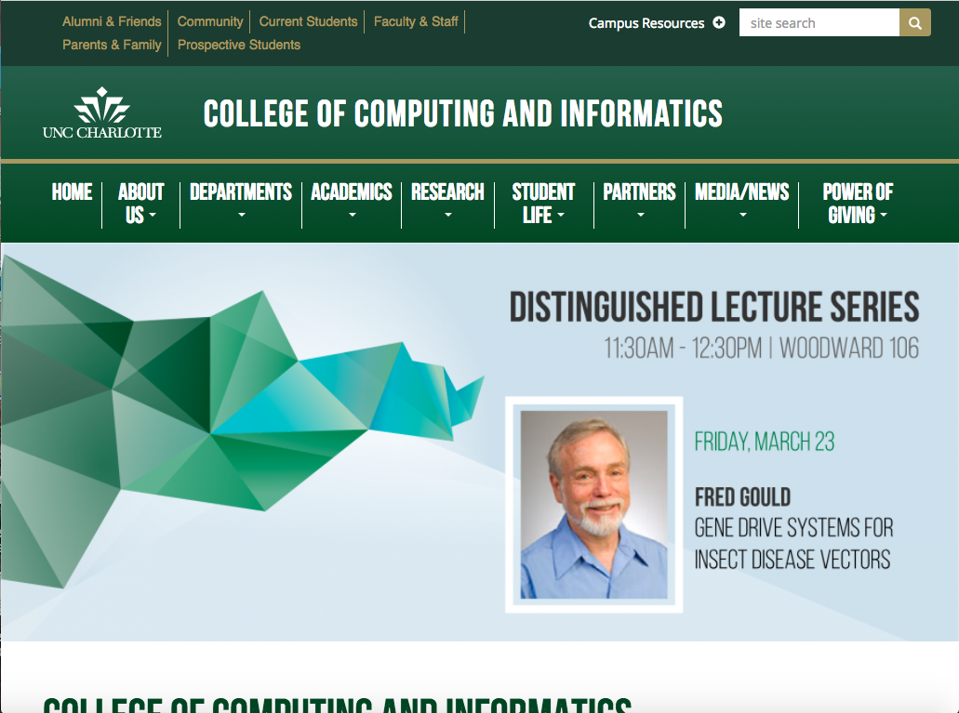

* The home page should have a little bit of whitespace on the left and right sides of the gallery.

1. **Layout:**

How is the content organized and located on a page? Is that appropriate?

What content (generally) appears above the fold, and what is below the fold?

How does the text layout facilitate finding information, and online reading?

**Our views:**

* The content size in the gallery is very large compared to the about us section and events.
* The user has to scroll if they want to see any other information because the content about the gallery is so huge.

.

* The two Menu bars can be merged and mapped to come up with a single Menu with comprehensive options and tabs.



* Adding important/relevant information about Events, Recent News, Apply tab below the fold at the bottom of the Web page takes away the significance and importance from these tabs.

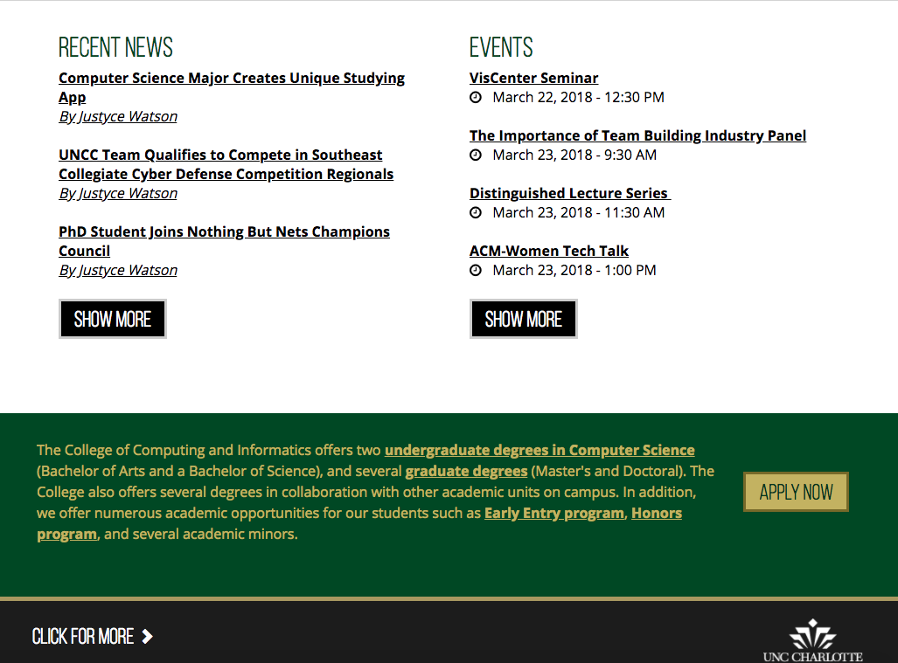

1. **Visual Design**

Comment on the style and effectiveness of the visual design – colors, graphics, fonts, etc... Does the visual design reinforce the organization of the content? What is the impact of the visual design? Is it consistent across the website?

**Our Views:**

* Use a gentle set of color (green, white and goldish) because these colors contain formal brand of UNCC.
* There is no uniformity of colors and font throughout the website, makes it seem non-cohesive.

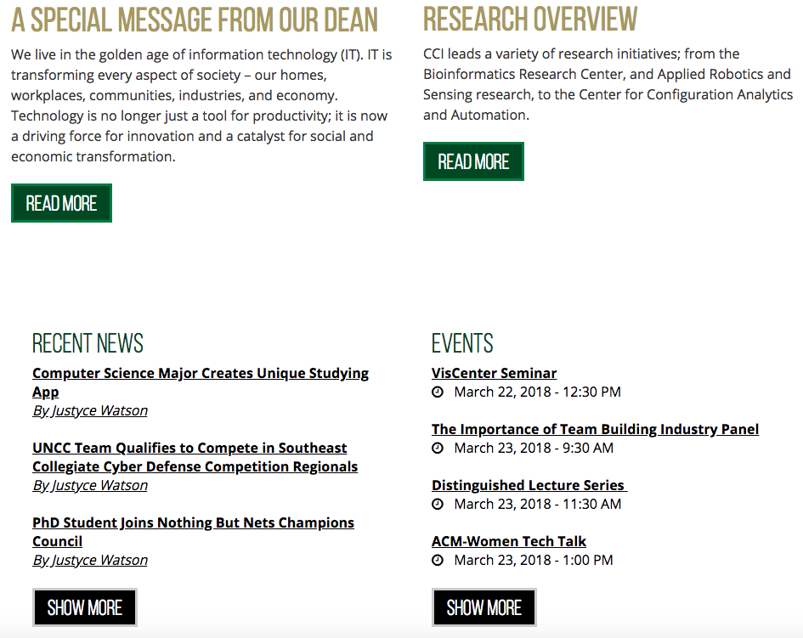

* There are not great graphics designs.
* The text under each section is not aligned and the content is not divided properly. The sections ‘special message from dean’ and the ‘CCI research’ has different content so making the ‘Read More’ button up and down.



1. **Navigation**

Are the methods for navigating between pages (via menus, links, etc.) understandable and usable? What methods help users understand where they are within the site? How are links, both within menus and within text, used and displayed? How easy or hard is it to move around the website?

**Our views:**

* Once the user clicks into a menus dropdown selection, it will display the hierarchy of that main menu which is great.
* We would highlight the menu to show which one the user is currently browsing.

For instance inside of Department Tab selection, after navigation inside the tab, no highlight is provided of the current user presence:

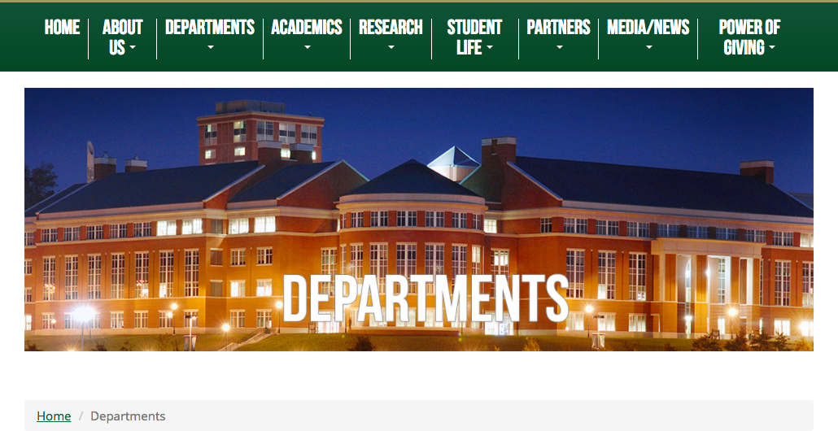

* It's not super difficult to navigate between the different pages although it requires a lot of scrolling.

1. **Overall Critique**

Overall, how effective is the design of the site? What is its best design feature, and what is its worst? Are there any other issues you have found on the site that you would like to see improved?

**Our views:**

* We believe the worst part about this website is the two menus at the top of the page. The top menu should be added into the main menus.
* The best feature of the website is the visual color scheme nothing conflicts with different colors and backgrounds.
* The content size of the images are not properly set to have less scrolling, and less error clicking. For example the user can accidentally click the scroll bar by simply trying to browse through images in the homepage gallery.